**Table of Contents**

|  |  |  |
| --- | --- | --- |
| **S. No.** | **Chapter** | **Page No.** |
| 1 | Project Description | 2-3 |
| 2 | Source Code | 4-33 |
| 3 | Screenshots | 34-40 |

**Chapter 1**

**Project Description – GAMER’S CAFÉ**

**OWNED BY-RAN47 GROUP**

The objective of this project to create front-end entertainment website that showcase my knowledge in HTML, CSS, JS, Bootstrap framework. The website designed in a way to be visually appealing by using animation effects, gradient colors as background.

The website includes multiple pages such as Login page, Home page, About page, Registration page, Contact page,. I used Bootstrap framework with the help of Font awesome cdn.The fonts used in this website is from Google’s fonts .

In Login page of our Travel Time website gets e-Mail and password, user credentials validation done through javascript code here it checks three conditions.

* Email should contain valid RegEx,
* The Input should not be empty or null,
* It checks the length of password that it should be more than 8 characters.

If above conditions satisfies with any of the inputs it marks green to the border of the specific input, otherwise it highlights the error input box with red color border with the error description.

In that same page , it has two links , one is for if they don’t have an account in Our website it redirects to the Registration page . In registration page it gets Username, Email , Password0020 along with reset button.

Home page contains a search input , logo and navigation links at the header section. This banner is achieved using CSS styles where background image property is used. The navigation bar styled through list where each list value having anchor tag which redirect to respective pages. Each page has home link which can redirect to the original home page. The restaurant page has starters,maincourse,rices,north-indian,dessert dishes. The “GAMERS PARADISE” has a lot of things and it is under development.

The interesting thing is that when we hover on the respected image it flip back and show the description of the specific dish. It rotates along Y direction at 180 degree to show the back content.

Then an offer division is given below to the flip boxes section with crispy discount description box and a ‘book now’ button. Following to that a Review Section is given , where the users review is displayed with the images.

Finally, the home page ends with a footer contains addresses, company details, and social media links to contact the office legally.

Following to that RAN47 Website has a About Page where the establishment and the Vision of the company is given. Then there are some important Team members of the company with their position and the contact number to connect with them. Then it comes to end of project description ,the following pages contains the source code and the screenshot of the website. Our\

Gaming product store website is being developed and in future a new webpage for movies will be created.

**Chapter 2**

**SOURCE CODE**

**LOGIN PAGE:**

<!DOCTYPE html>

<html lang="en">

<head>

<meta charset="UTF-8">

<meta http-equiv="X-UA-Compatible" content="IE=edge">

<meta name="viewport" content="width=device-width, initial-scale=1.0">

<script src="login.js" defer></script>

<title>login</title>

<link rel="stylesheet" href="login.css">

<link href="https://fonts.googleapis.com/css2?family=Bruno+Ace+SC&display=swap" rel="stylesheet">

<link rel="stylesheet" href="https://cdnjs.cloudflare.com/ajax/libs/font-awesome/6.4.0/css/all.min.css">

<style>

body{

background-image: url(38882.png);

background-size: cover;

}

@media only screen and (max-width:700px){

input{

padding: 8px 20px;

}

label{

font-size: 110%;

}

h1{

font-size: 240%;

}

button{

padding: 6px 20px;

}

#reset{

padding: 3px 6px;

}

#form{

width: 90%;

margin-top: 80px;

margin-left:4% ;}}

</style>

</head>

<body>

<h2 style="text-align: center;color:aliceblue"><a href="index.html" style="text-decoration: none;color: aliceblue;"><i class="fa-solid fa-house"></i>HOME</a></h2>

<form id="form" onsubmit=" validateInputs()" action="login.html">

<h1 style="font-family:'Gill Sans', 'Gill Sans MT', Calibri, 'Trebuchet MS', sans-serif">Login</h1>

<div class="input-group">

<label for="email">E-Mail Id :</label>

<input type="text" id="email" name="email" placeholder="abc@gmail.com"><br>

<div class="error"></div>

</div>

<div class="input-group">

<label for="pass">Password :</label>

<input type="password" id="password" name="pass" placeholder="123@4567"><i toggle="#password-field" class="fa fa-fw fa-eye field-icon toggle-password" style="color:orange" onclick="viewpass()" id="passview"></i><br>

<div class="error"></div>

</div>

<button type="submit">Login</button>

<center>

<p style="color:white">Don't have an account?</p><a href="signin.html" style="text-decoration: none;color:yellow">REGISTER</a>

<p></p></center>

</form>

<script>

function viewpass(){

var passwordinput=document.getElementById("userpsw");

var passstatus=document.getElementById("passview");

if (passwordinput.type === 'password'){

passwordinput.type='text';

}

else{

passwordinput.type="password";

passstatus.innerhtml='<i class="fa-solid fa-eye-slash"></i>';

}

}

</script>

</body>

</html>

**LOGIN PAGE CSS:**

*{

border:0;

margin:0;

}

h1{

text-align: center;

margin-top: 10px;

color:whitesmoke;

font: weight 200px;

}

.log{

background-color:rgba(0,0,0,0.7);

width:40%;

padding-top:20px;

padding-bottom:20px;

border-radius: 40px;

margin:5em auto;

display: flex;

justify-content: center;

box-shadow: 5px 5px 5px 5px whitesmoke;

}

.fom{

font-weight:550px;

font-style:normal;

color: white;

}

.group{

display: block;

justify-content: center;

}

.group input{

font-size:1.5em;

width:100%;

border: 2px;

border-radius: 8px;

padding: 2px 10px;

box-sizing:border-box;

margin:5px 0px 10px;

}

.but{

padding:10px 50px;

font-size: 17px;

cursor:pointer;

border-radius: 10px;

padding:3px 20px;

}

**LOGIN PAGE JAVASCRIPT:**

const form = document.querySelector('#form')

const firstname = document.querySelector('#firstname');

const lastname = document.querySelector('#lastname');

const email = document.querySelector('#email');

const password = document.querySelector('#password');

const conpass= document.querySelector('#conpass');

form.addEventListener('submit',(e)=>{

if(!validateInputs()){

e.preventDefault();

}

})

function validateInputs(){

const emailVal = email.value.trim();

const passwordVal = password.value.trim();

let success = true

if(emailVal===''){

success = false;

setError(email,'Email is required')

}

else if(!validateEmail(emailVal)){

success = false;

setError(email,'Please enter a valid email')

}

else{

setSuccess(email)

}

if(passwordVal === ''){

success= false;

setError(password,'Password is required')

}

else if(passwordVal.length<8){

success = false;

setError(password,'Password must be atleast 8 characters long')

}

else{

setSuccess(password);

}

return success;

}

function setError(element,message){

const inputGroup = element.parentElement;

const errorElement = inputGroup.querySelector('.error')

errorElement.innerText = message;

inputGroup.classList.add('error')

inputGroup.classList.remove('success')

}

function setSuccess(element){

const inputGroup = element.parentElement;

const errorElement = inputGroup.querySelector('.error')

errorElement.innerText = '';

inputGroup.classList.add('success')

inputGroup.classList.remove('error')

}

const validateEmail = (email) => {

return String(email)

.toLowerCase()

.match(

/^(([^<>()[\]\\.,;:\s@"]+(\.[^<>()[\]\\.,;:\s@"]+)*)|(".+"))@((\[[0-9]{1,3}\.[0-9]{1,3}\.[0-9]{1,3}\.[0-9]{1,3}\])|(([a-zA-Z\-0-9]+\.)+[a-zA-Z]{2,}))$/

);

};

**RESTAURANT PAGE:**

<!DOCTYPE html>

<html lang="en">

<head>

<meta charset="UTF-8">

<meta http-equiv="X-UA-Compatible" content="IE=edge">

<meta name="viewport" content="width=device-width, initial-scale=1.0">

<link rel="stylesheet" href="https://cdnjs.cloudflare.com/ajax/libs/font-awesome/6.1.2/css/all.min.css">

<link rel="stylesheet" href="resta.css">

<link rel="icon" href="/media/favicon.ico">

</head>

<title>PALM SHORE</title>

<style>

.thecard{

position: relative;

top: 0;

left: 0;

width: 100%;

height: 100%;

border-radius: 10px;

transform-style: preserve-3d;

transition: all 0.8s ease;

}

/* THE PSUEDO CLASS CONTROLS THE FLIP ON MOUSEOVER AND MOUSEOUT */

.thecard:hover {

transform: rotateY(180deg);

}

/* THE FRONT FACE OF THE CARD, WHICH SHOWS BY DEFAULT */

.thefront{

position: absolute;

top: 0;

left: 0;

width: 100%;

height: 100%;

border-radius: 10px;

backface-visibility: hidden;

overflow: hidden;

color: #000;

}

/* THE BACK FACE OF THE CARD, WHICH SHOWS ON MOUSEOVER */

.theback{

margin:auto;

margin-top:10px;

width: 90%;

height:90%;

padding-top:10px;

border-radius: 20px;

backface-visibility: hidden;

overflow: hidden;

background: #fafafa;

color: #333;

transform:rotateY(180deg);

}

/*This block (starts here) is merely styling for the flip card, and is NOT an essential part of the flip code */

.thefront h1, .theback h1{

font-family: 'zilla slab', sans-serif;

padding: 30px;

font-weight: bold;

font-size: 50px;

text-align: center;

}

.thefront p, .theback p{

font-family: 'zilla slab', sans-serif;

padding: 30px;

font-weight: normal;

font-size: 20px;

text-align: center;

}

</style>

</head>

<body>

<div class="landing">

<header>

<a href="index.html" id="logo"><h2><i class="fa-solid fa-bowl-rice"></i>THE GAMERS'S CAFE</h2></a>

<nav>&nbsp; &nbsp;&nbsp;&nbsp;&nbsp;&nbsp;&nbsp;&nbsp;&nbsp;&nbsp;

<a href="#locheading"><i class="fa-solid fa-location-pin"></i>Locations</a>

<a href="yt.html">YT</a>

</nav>

</header>

<div class="maintext">

<div class="tagline1">

Finest Treat for Your Taste Buds.<br>

SUDA SUDA!

</div><br>

<div class="tagline2">

Fastest Delivery

</div><br>

<div class="callus">

Call us @+91 xxxxxxxxxx

</div><br>

<button style="cursor: pointer;">Order Online</button>

<br>

<br>

<div>

<label for="menu" style="background-color: #53BF9D;border-radius: 10px;padding:10px;height:20px;width:30px;">MENU</label>

<select name="menuit" id="menu" style="height:50px" onchange="this.options[this.selectedIndex].value && (window.location = this.options[this.selectedIndex].value);">

<option value="#start" >STARTERS</option>

<option value="#maincourse">MAINCOURSE</option>

<option value="#desserts">DESSERTS</option>

<option value="#northindian" selected>NORTH-INDIAN</option>

<option value="#rices">RICES</option>

</select>

</div>

<div style="text-align: right;">

<h1 style="color: aqua;font-family: 'Gill Sans', 'Gill Sans MT', Calibri, 'Trebuchet MS', sans-serif;">IF U R A GAMER CLICK HERE!</h1>

<a href="game.html"><button style="cursor:grab;font-size: 15px;">GAMERS CLICK HERE!</button></a>

</div>

</div>

<div class="offer">

<marquee>90% OFFER ON 1ST ORDER!</marquee>

</div>

</div>

<h2 id="menuheading">Menu</h2>

<div id="start" style="height:50px">STARTERS</div>

<div class="starters">

<div class="contain">

<div class="thecard">

<div class="thefront">

<img src="panner tikka2.jpg" class="img">

<br>

<h2>PANNER TIKKA</h2>

</div>

<div class="theback">

<p class="p2">Paneer tikka or Paneer Soola or Chhena Soola is an Indian dish made from chunks of paneer/ chhena marinated in spices and grilled in a tandoor. It is a vegetarian alternative to chicken tikka and other meat dishes. </p>

<h3>&#8377 80</h3>

<input type="button" value="ORDER" onclick="msg()">

</div>

<br>

</div>

</div>

<br>

<div class="contain">

<div class="thecard">

<div class="thefront">

<img src="chilli gobi.jpg" class="img">

<br>

<h2>CHILLI GOBI</h2>

</div>

<div class="theback">

<p class="p2">Chilli gobi recipe with step by step pictures. Absolutely delicious is this restaurant style chilli gobi recipe from the Indo Chinese cuisine. You just cannot stop eating these crispy and spicy cauliflower florets. This cauliflower chilli makes an awesome starter or snack at family dinners or get-togethers.</p>

<h3>&#8377 80</h3>

<input type="button" value="ORDER">

</div>

<br>

</div>

</div>

<br>

<div class="contain">

<div class="thecard">

<div class="thefront">

<img src="gobi 65.jpg" class="img">

<br>

<h2>GOBI 65</h2>

</div>

<div class="theback">

<p class="p2">Spicy and crispy Gobi 65 recipe is a fried cauliflower appetizer or snack that everyone will love! It’s vegan, and simple to make with my step-by-step photos and recipe. Crunchy and savory Cauliflower 65 is perfect to serve with tomato ketchup, red chili sauce, chutneys, or your favorite condiment to dip. </p>

<h3>&#8377 80</h3>

<input type="button" value="ORDER">

</div>

<br>

</div>

</div>

<div class="contain">

<div class="thecard">

<div class="thefront">

<img src="mulaga bajji.jpg" class="img">

<br>

<h2>MULAGA BAJJI</h2>

</div>

<div class="theback">

<p class="p2">This is one of those recipes in which, you will be able to enjoy chillies without their spiciness. Thus, this Mirchi Bajji is also a popular one at my home and I make it on many occasions. Since, there’s no heat from the chilies in this recipe, it is liked by one and all.</p>

<h3>&#8377 30</h3>

<input type="button" value="ORDER">

</div>

<br>

</div>

</div>

<div class="contain">

<div class="thecard">

<div class="thefront">

<img src="veg pakoda.jpg" class="img">

<br>

<h2>VEG PAKODA</h2>

</div>

<div class="theback">

<p class="p2">Make crispy and tasty mixed Vegetable pakora recipe with my easy step-by-step photo guide. Easy to customize with your favorite vegetables, this veg pakora has a crispy, crunchy exterior with a soft interior. The recipe is naturally vegan and can be made gluten-free.</p>

<h3>&#8377 30</h3>

<input type="button" value="ORDER">

</div>

<br>

</div>

</div>

<div class="contain">

<div class="thecard">

<div class="thefront">

<img src="Bonda.jpg" class="img">

<br>

<h2>BONDA</h2>

</div>

<div class="theback">

<p class="p2">These are like soft and spongy fritters made with all purpose flour, spices and herbs. Since all-purpose flour or maida is one of the primary ingredients in these bajjis, these are also called Maida Bonda. This recipe of mine is vegan and with it, you can make these scrumptious bondas easily at home.</p>

<h3>&#8377 30</h3>

<input type="button" value="ORDER">

</div>

<br>

</div>

</div>

<div class="contain">

<div class="thecard">

<div class="thefront">

<img src="tomatosoup.jpg" class="img">

<br>

<h2>TOMATO SOUP</h2>

</div>

<div class="theback">

<p class="p2"> This delicious soup is one of the many ways to use the bright red tomato produce at our homes. This homestyle Cream of Tomato Soup is smooth, tangy and oh so creamy, without any cream added!</p>

<h3>&#8377 30</h3>

<input type="button" value="ORDER">

</div>

<br>

</div>

</div>

</div>

<br>

<div id="maincourse" style="height:50px;">MAINCOURSE</div>

<div class="mainitems">

<div class="maincontain">

<img src="Idli.png" class="img">

<br>

<h2>IDLI</h2>

<h3>&#8377 20</h3>

<input type="button" value="ORDER">

</div>

<div class="maincontain">

<img src="Dosa.png" class="img">

<br>

<h2>DOSA</h2>

<h3>&#8377 38</h3>

<input type="button" value="ORDER">

</div>

<div class="maincontain">

<img src="chapatti.jpg" class="img">

<br>

<h2>CHAPATTI</h2>

<h3>&#8377 60</h3>

<input type="button" value="ORDER">

</div>

<div class="maincontain">

<img src="pongal.png" class="img">

<br>

<h2>PONGAL</h2>

<h3>&#8377 40</h3>

<input type="button" value="ORDER">

</div>

<div class="maincontain">

<img src="poori.jpg" class="img">

<br>

<h2>POORI</h2>

<h3>&#8377 20</h3>

<input type="button" value="ORDER">

</div>

<div class="maincontain">

<img src="Upma.jpg" class="img">

<br>

<h2>UPMA</h2>

<h3>&#8377 40</h3>

<input type="button" value="ORDER">

</div>

</div>

<br>

<br>

<br>

<div class="both">

<div id="northindian">

<h1>NORTH-INDIAN</h1>

<div class="maincontain">

<img src="panner butter.jpg" class="img">

<br>

<h2>PANNER BUTTER MASALA</h2>

<h3>&#8377 100</h3>

<input type="button" value="ORDER">

</div>

<div class="maincontain">

<img src="Butter-Naan.jpg" class="img">

<br>

<h2>BUTTER-NAAN</h2>

<h3>&#8377 60</h3>

<input type="button" value="ORDER">

</div>

<div class="maincontain">

<img src="palak panner.jpg" class="img">

<br>

<h2>BUTTER-NAAN</h2>

<h3>&#8377 60</h3>

<input type="button" value="ORDER">

</div>

</div>

<div id="rices">

<h1>RICES</h1>

<div class="maincontain">

<img src="chickenbiriyani.jpg" class="img">

<br>

<h2>CHICKEN BIRIYANI</h2>

<h3>&#8377 120</h3>

<input type="button" value="ORDER">

</div>

<div class="maincontain">

<img src="Muttonbiriyani.jpg" class="img">

<br>

<h2>MUTTON BIRIYANI</h2>

<h3>&#8377 140</h3>

<input type="button" value="ORDER">

</div>

<div class="maincontain">

<img src="sezwanrice.jpg" class="img">

<br>

<h2>SEZWAN FRIED RICE</h2>

<h3>&#8377 100</h3>

<input type="button" value="ORDER">

</div>

<div class="maincontain">

<img src="vegfriedrice.jpg" class="img">

<br>

<h2>VEG FRIED RICE</h2>

<h3>&#8377 100</h3>

<input type="button" value="ORDER">

</div>

</div>

</div>

<div id="desserts" style="text-align: center;">

<H1>DESSERTS</H1>

<div class="detcontain">

<div class="maincontain">

<img src="fruitsaladice.jpeg" class="img">

<br>

<h2>SALAD</h2>

<h3>&#8377 100</h3>

<input type="button" value="ORDER">

</div>

<div class="maincontain">

<img src="brownie with ice cream.jpg" class="img">

<br>

<h2>SALAD</h2>

<h3>&#8377 100</h3>

<input type="button" value="ORDER">

</div>

</div>

</div>

<h2 id="locheading">Locations</h2>

<div class="locations">

<div class="velachery">

<h2>Velachery</h2>

<address>

5, 3rd Road,</br>

Aarana Nagar,</br>

Velachery,</br>

Chennai - 600042

</address>

</div>

<div class="Tambaram">

<h2>Tambaram</h2>

<address>

145, MIT Road,</br>

SATUR,</br>

VIRDHUNAGAR - 600045

</address>

</div>

</div>

<footer>

<div id="copyright">&copy; copyright THE GAMER'S CAFE</div>

</footer>

<script>

function msg(){

alert("ADDED TO CART!");

}

</script>

</body>

</html>

**RESTAURANT CSS:**

*{

margin: 0;

padding: 0;

box-sizing: border-box;

font-family: 'Poppins', sans-serif;

}

body,h2{

margin:0;

font-family: Arial, Helvetica, sans-serif;

}

:root{

--red:crimson;

--green:#53BF9D;

--yellow:#FFC54D;

--white:whitesmoke;

}

.landing{

background:transparent;

background-size: cover;

background-image: url(1.jpg);

backgrwound-position: center;

height:125vh;

color:var(--white);

}

header a{

text-decoration: none;

color:var(--yellow);

min-width: 120px;

}

header{

display:flex;

justify-content: space-between;

row-gap:2em;

padding:1em;

}

#logo{

flex:3;

font-size:1.25em;

min-width:260px;

}

nav{

flex:2;

display:flex;

align-items: center;

}

nav a{

flex:2;

}

.maintext{

height: 20px;

justify-content: center;

padding:16px;

}

.tagline1{

color:red;

font-size:2.5em;

font-weight: bolder;

}

.tagline2{

color:var(--yellow);

}

.maintext button{

width:20vw;

margin-top:2em;

border-radius:10px;

padding:.7em;

background-color: #53BF9D;

color:var(--white);

border: 1px solid var(--green);

}

.maintext div{

margin-top:.75em;

}

#menuheading,#locheading{

background:rgb(100,150,125);

font-size:2.5em;

color:var(--red);

display: flex;

justify-content: center;

}

.menu th{

color:var(--green);

font-size: 1.8em;

}

.locations{

background:rgb(53, 52, 52);

color:var(--white);

display:flex;

flex-wrap:wrap;

}

.locations h2{

color:var(--green);

margin-bottom: .8em;

}

.locations div{

flex:1;

padding:1em;

min-width:220px;

}

footer{

background-color: rgb(55, 55, 55);

color:whitesmoke;

padding:.25em 1em;

}

.dropdown {

display: inline-block;

position: relative;

}

button:hover{

background-color:#ddd;

}

.dropdown-options {

display: none;

position: absolute;

overflow: auto;

background-color:#fff;

border-radius:5px;

box-shadow: 0px 10px 10px 0px rgba(0,0,0,0.4);

}

.dropdown:hover .dropdown-options {

display: block;

}

.dropdown-options a {

display: block;

color: #000000;

padding: 5px;

text-decoration: none;

padding:20px 40px;

}

.dropdown-options a:hover {

color: #0a0a23;

background-color: #ddd;

border-radius:5px;

}

#start,#maincourse{

height: 40px;

font-size: 30px;

text-align: center;

font-weight: 600;

font-style: bold;

color:rgb(209, 1, 1);

background-image:linear-gradient( to right,black,rgb(61, 61, 61));

padding:10px;

}

.starters{

display: flex;

flex-wrap:wrap;

width:100%;

}

.p2{

font-family: Cambria, Cochin, Georgia, Times, 'Times New Roman', serif;

font-size: 1em;

}

.ima{

height:20em;

width: 20em;

border-radius:30px;

cursor:pointer;

padding-top: 5px;

}

.contain{

margin:auto;

width:25em;

height:25em;

display:flex;

text-align: center;

align-items: center;

flex-direction: column;

}

.contain input{

width: 40%;

border-radius: 10px;

font-size: 20px;

cursor:pointer;

}

.contain{

background-color: #FFC54D;

border-radius:40px;

margin-top:10px;

}

.img{

height:20em;

width:16em;

border-radius:30px;

cursor:pointer;

padding-top: 10px;

}

.starters{

margin:auto;

}

.mainitems{

display:flex;

flex-direction: row;

overflow-x:scroll;

overflow-y:hidden;

}

.maincontain{

margin:5px;

padding:5px;

border:2px solid yellow;

}

.both{

display:flex;

justify-content: space-between;

}

#northindian{

width:40%;

}

#northindian h1{

text-align:center;

}

#northindian>div{

text-align: center;

border:none;

background:radial-gradient(yellow,red);

border-radius: 20px;

}

#rices{

width:40%;

justify-content: center;

}

#rices h1{

text-align: center;

}

#rices>div{

text-align: center;

border:none;

background:radial-gradient(black,white);

border-radius: 20px;

}

.detcontain{

width: 40%;

margin:auto;

display:flex;

flex-direction: column;

height:500px;

overflow: scroll;

}

.detcontain>div{

padding:30px;

}

footer{

text-align: center;

}

.locations{

text-align: center;

}

.offer{

width:40%;

display:absolute;

z-index:1;

background-color: transparent;

}

@-ms-viewport{

width: device-width;

}

**Chapter-3**

**SCREEN SHOTS**

**LOGIN PAGE:**

a)Login page with email id and password

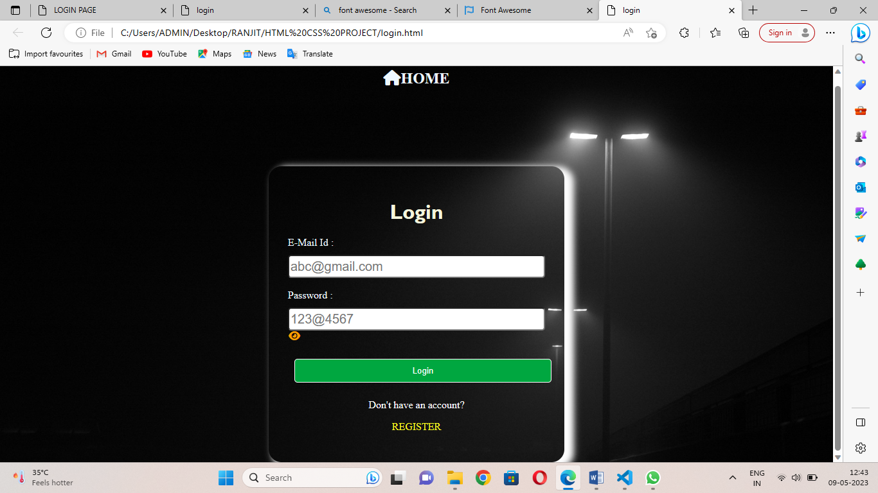

b)Login page with form validation.

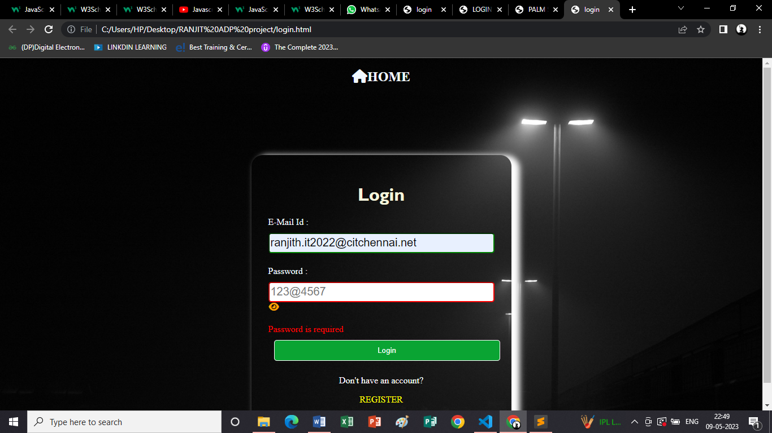

**SIGN-IN PAGE:**

a)New users can register proving their username email and password.

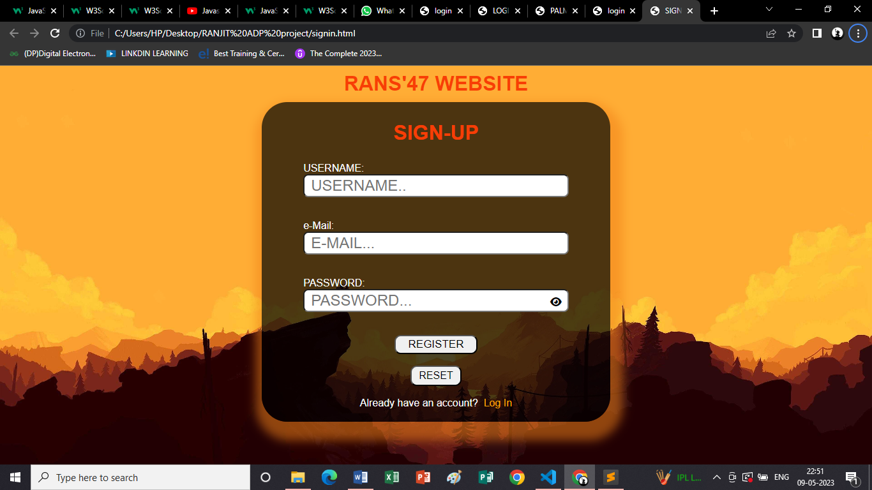

b)Sign-in page with validation.

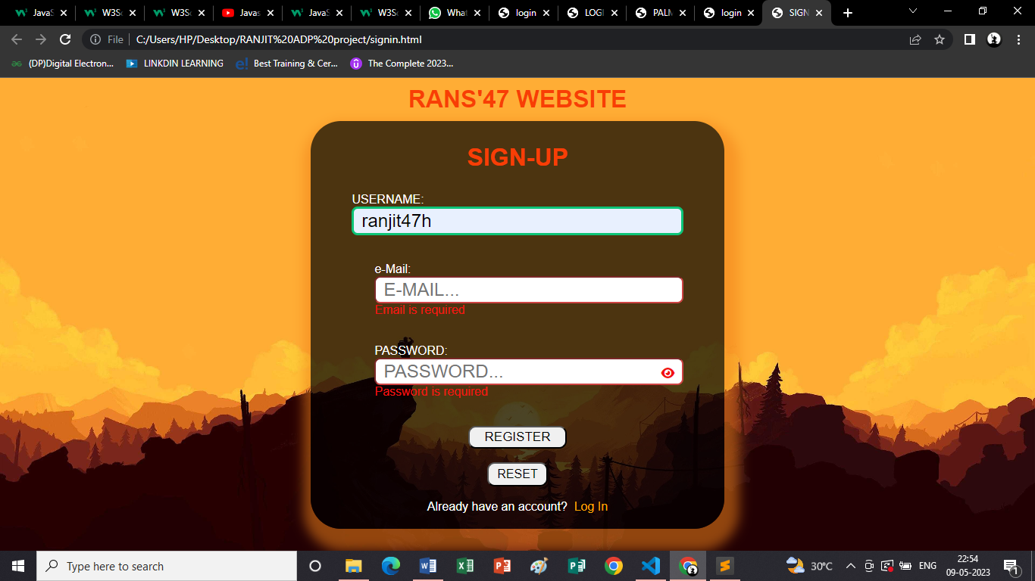

**INDEX-PAGE:**

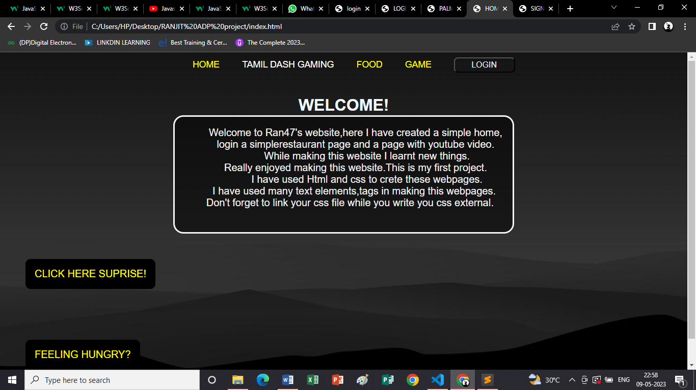

**YOUTUBE:**

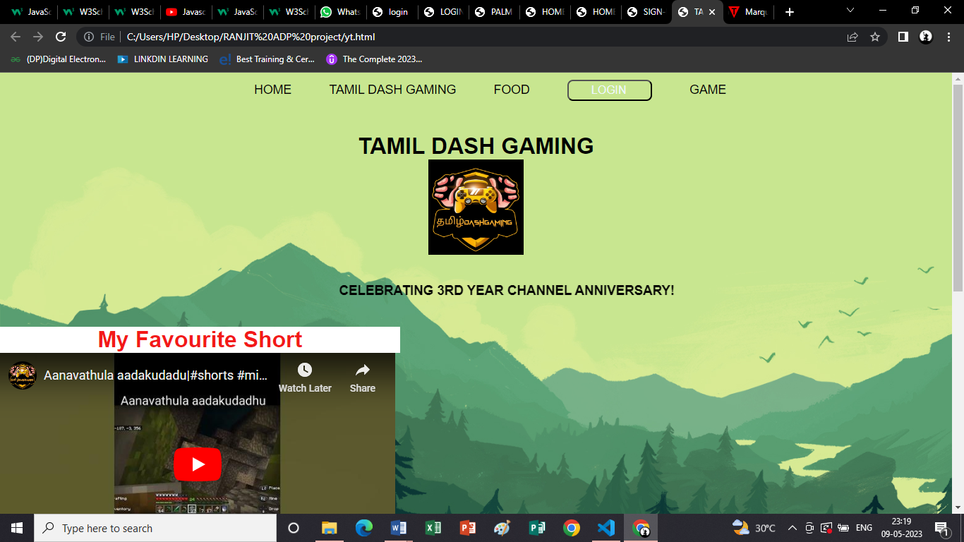

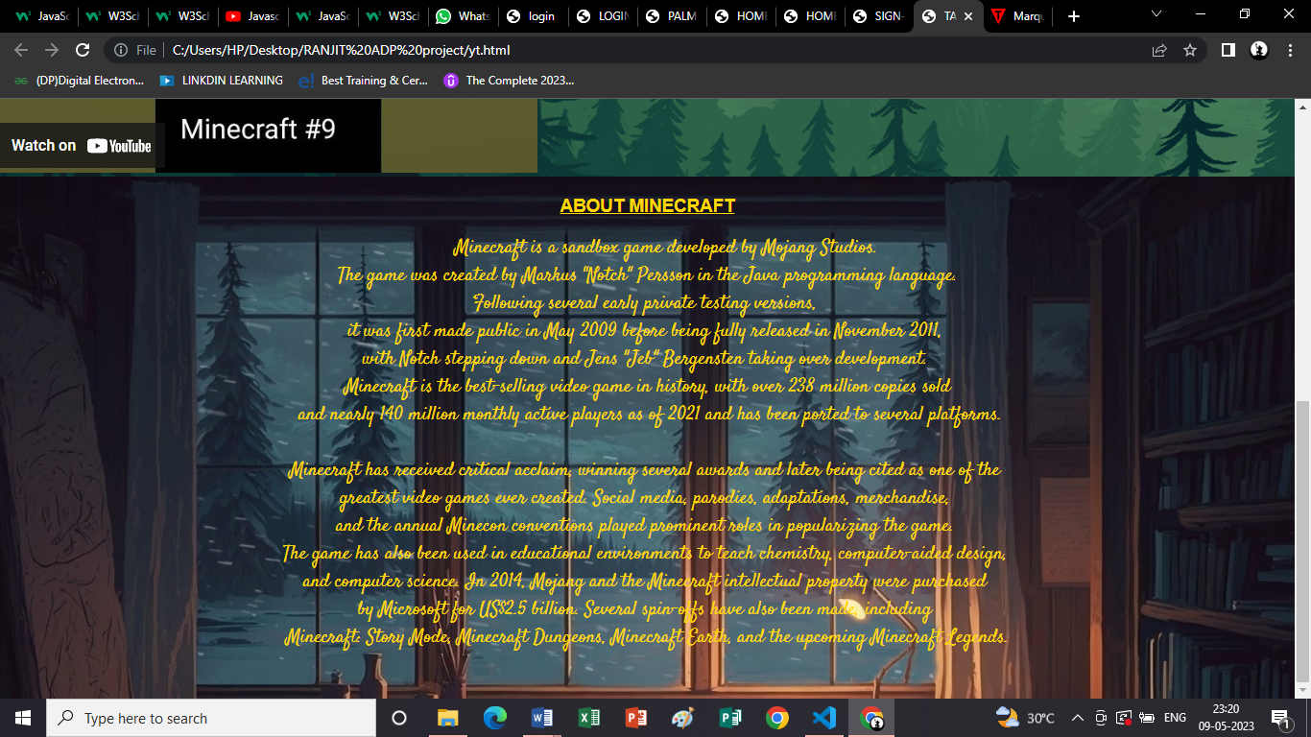

**RESTAURANT:**

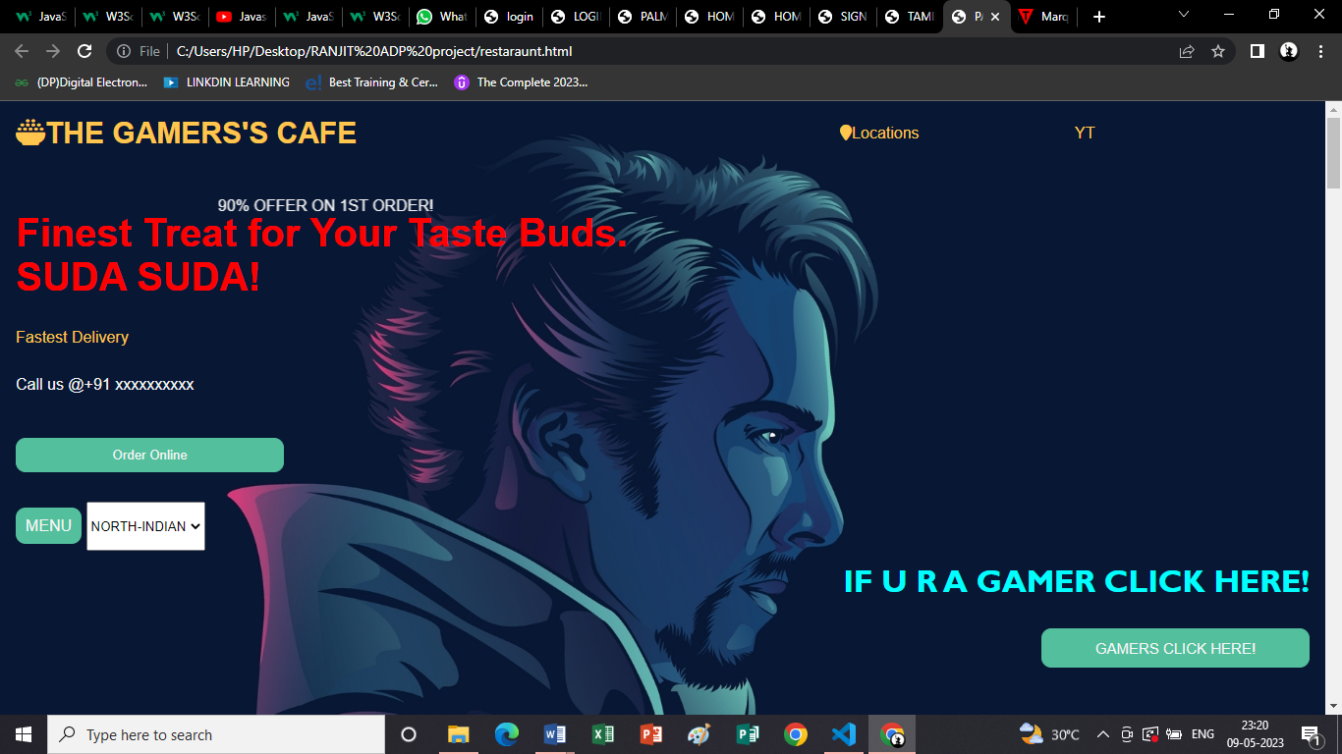

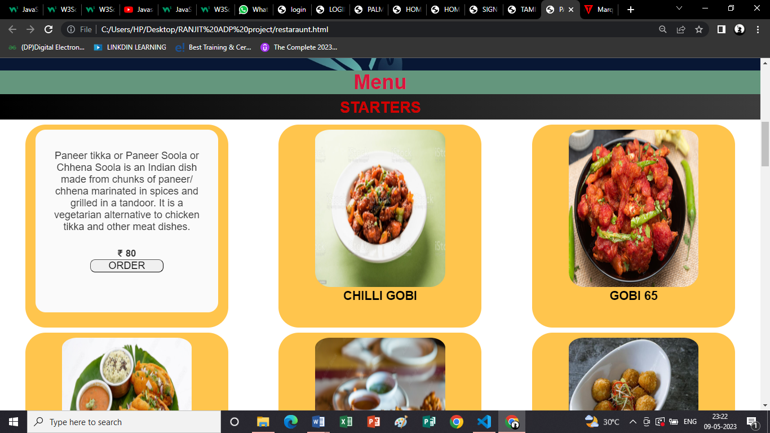

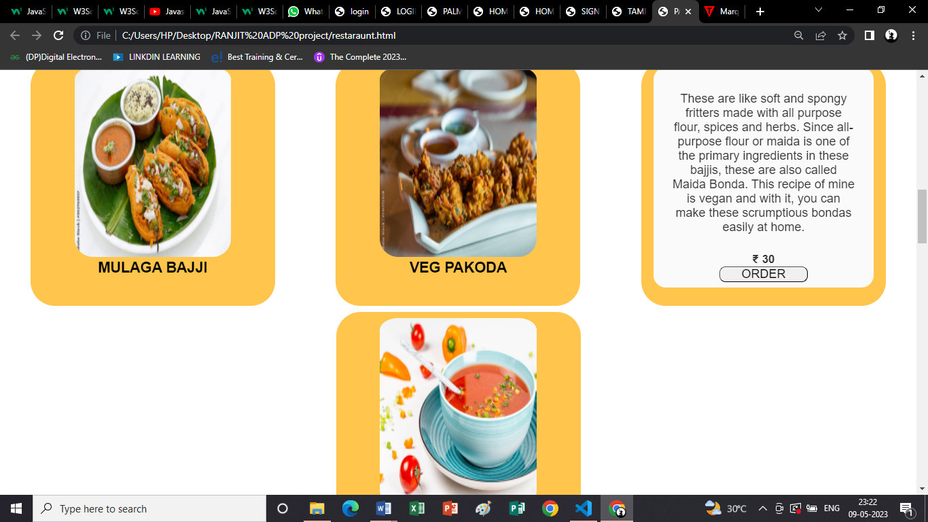

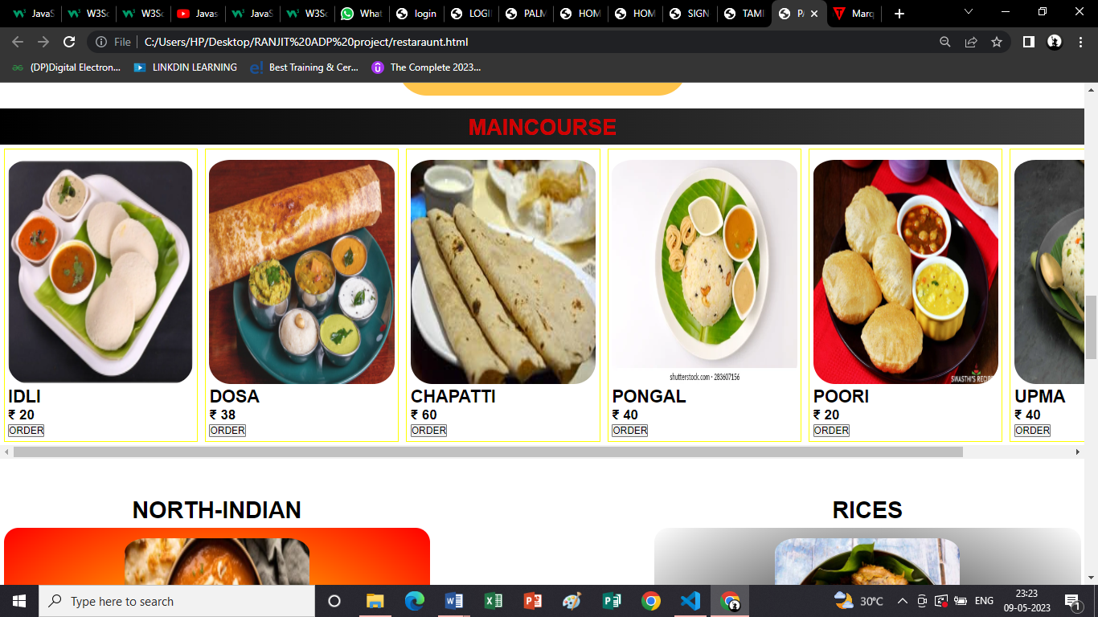

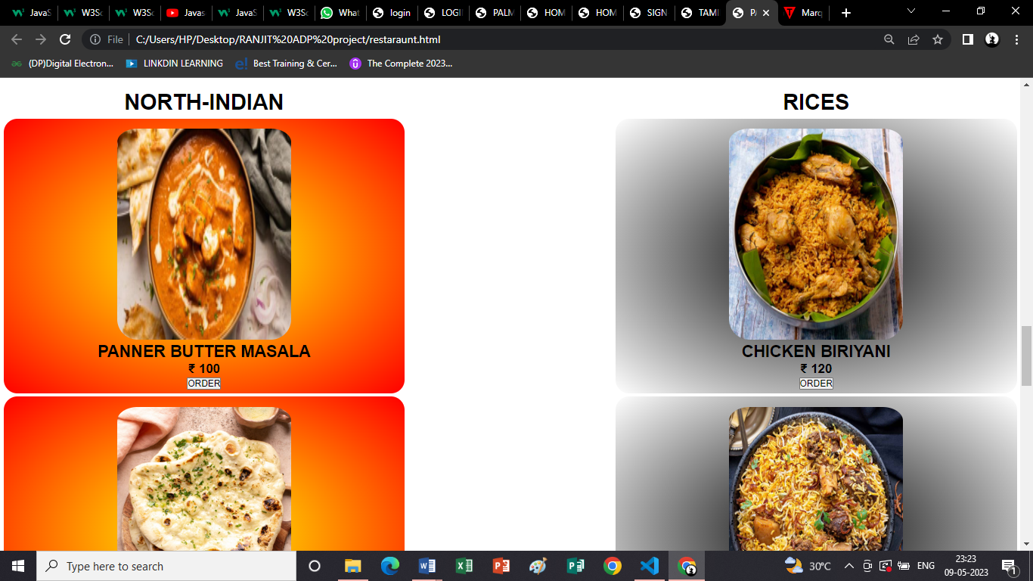

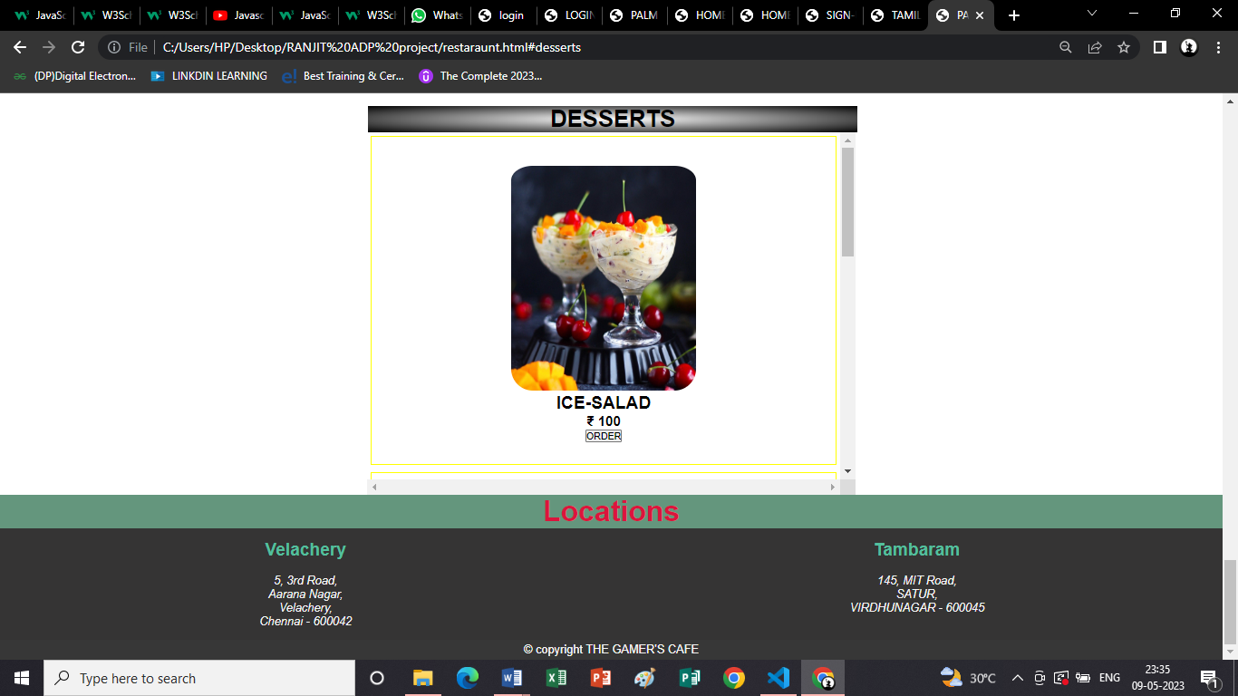

**GAME PAGE:**



